Necrology Directions and Forms
2021-2023

Upon the death of a chapter member the chapter president or her designee needs to collect and complete:

- Form 6 Death of a Member 2/24/16 Revision (5 copies needed)
- the newspaper or online obituary (3 copies or originals)
- a profile of a few short paragraphs including information listed on the profile template. (2 copies needed.)

1. Mail or email to the International Membership Services Administrator: mem@dkg.org
12710 Research Blvd, Suite 230, Austin, TX 78759
- Form 6

2. Mail or email to State Treasurer, Ellen Festi: festi316@yahoo.com
122 West Stafford Rd, Stafford Springs, CT 06076
- Form 6

3. Mail or email to State President, Dr. Ann Cavanaugh Grosjean, acgrosjean@gmail.com
11 Birch Meadow Lane, Willington, CT 06279
- Form 6 A copy of the form to the President is not stated on Form 6 but is necessary because the state president acknowledges the chapter’s loss.
- the newspaper obituary.

4. Mail or email to State Membership Necrology Chair, Sandra Gammons
8 Chinmoy Lane, New Milford, CT 06776; email: shgamm@gmail.com
- Form 6 A copy of the form to the President is not stated on Form 6 but is necessary because the state president acknowledges the chapter’s loss.
- the newspaper obituary.
- a profile of a few short paragraphs which including information on the outline attached detailing the name of the deceased member, the name of the member’s chapter, the date of death and a description of the member, her career of work and her service to chapter, state and international.

5. The Chapter President retains a printed copy of Form 6, the obituary, and the profile for the chapter files.

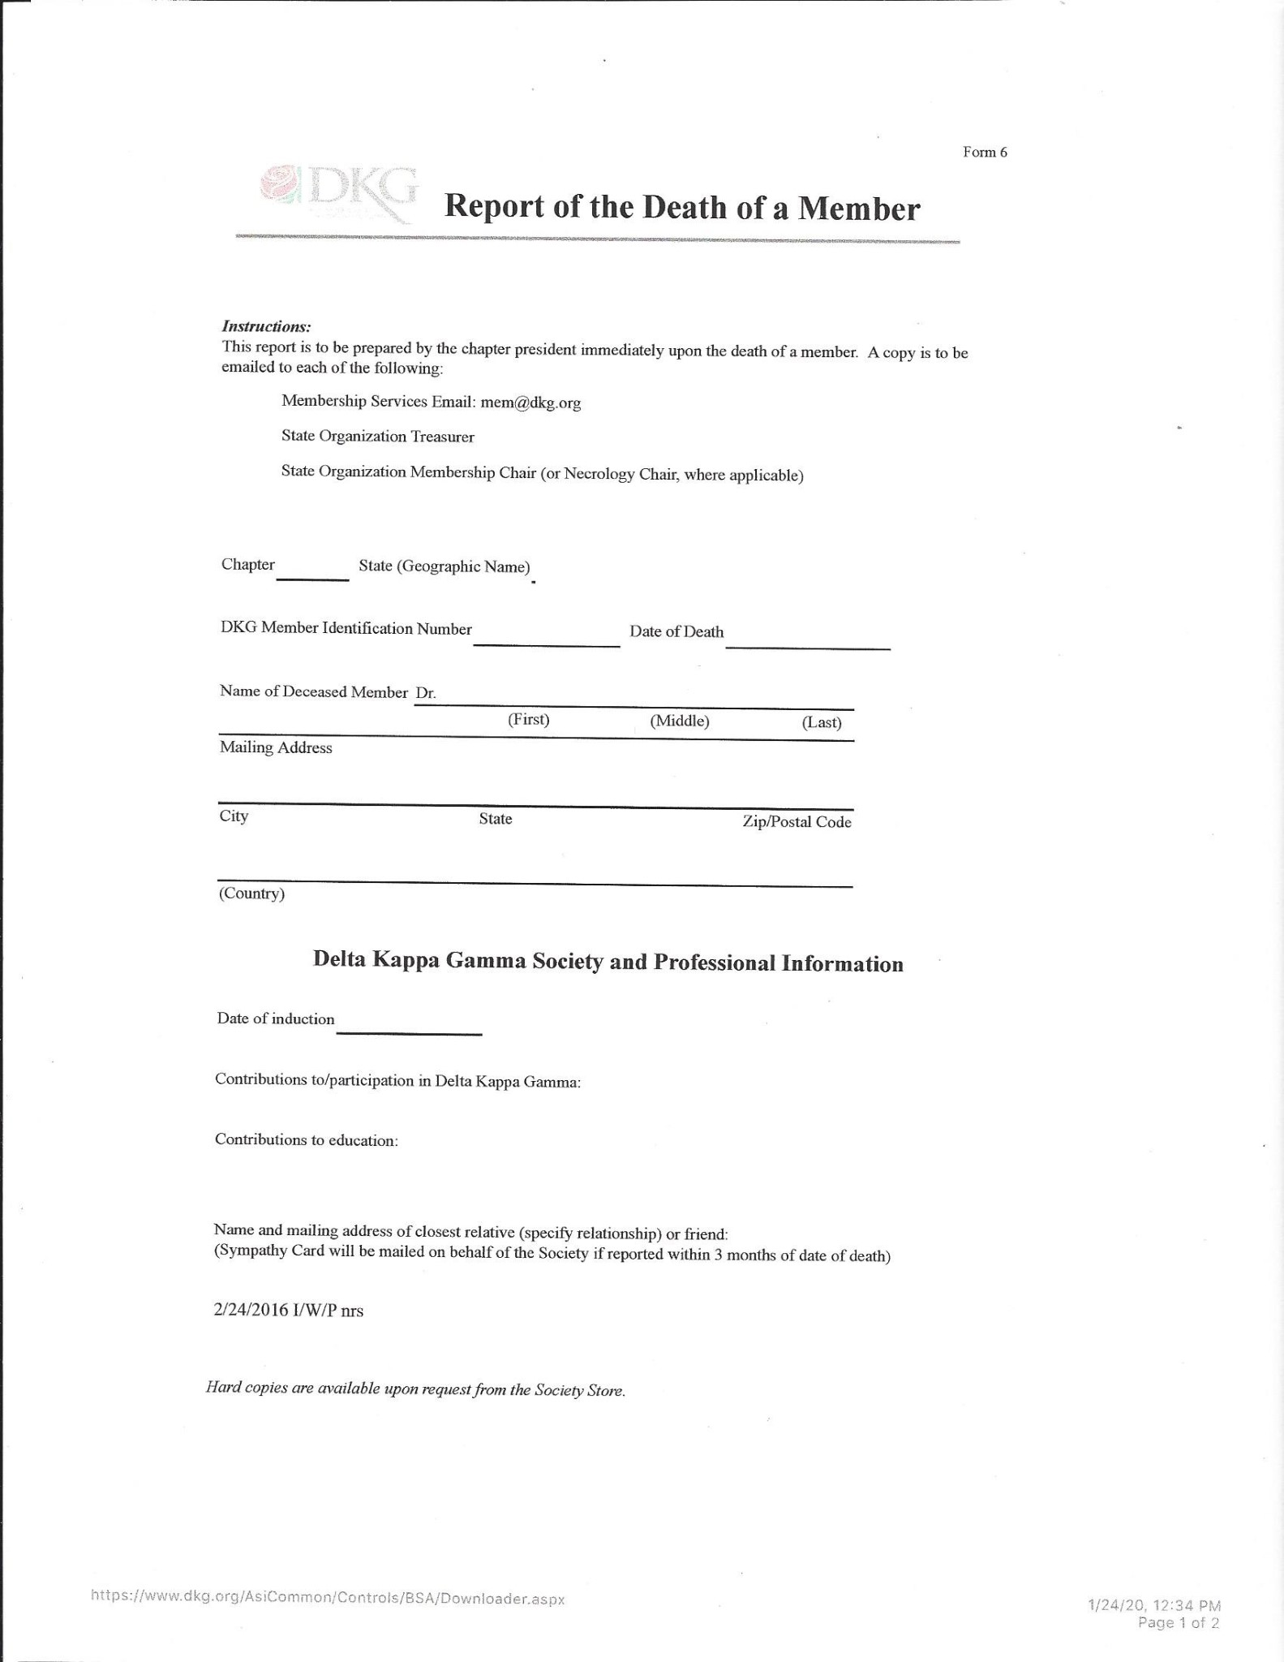

GUIDE TO NECROLOGY PROFILE

This profile template is included as a possible format to use when writing about your deceased chapter member. You should submit it as you would like it to appear in the Celebration of Life Booklet but it needs to be in complete sentences and paragraph form. The Necrology Chair will edit the content, if necessary. The profile needs to be a maximum of one 9x11 page in length using size 12 font but most are shorter. If you don’t know enough about the deceased member, you should ask chapter members who knew her to add additional information. You may also include relevant information from the obituary.

This profile should be submitted to the Necrology Chair as soon as completed to accompany Form 6 and the obituary.

Heading

Member’s name, _______Chapter
Date of passing

Include in Paragraph #1: DKG /CT State/ Chapter Information
Initiation Date
Chapter into which she was initiated. - If she was initiated into another chapter, the date she transferred into your chapter.
Contributions she has made to your chapter, to AKS, and DKG. Include positions held, presentations, etc. as well as unofficial contributions.

Include in Paragraph #2: Educational Background
Degrees received, dates received, and college or University
Additional educational accomplishments

Include in Paragraph #3: Professional Accomplishments/ Work History
Include schools/ universities where she taught, positions held, and number of years in these positions.

Include in Paragraphs #4 and #5
Community involvement, places she volunteered, any personal and or professional information you and your chapter would like to include about your chapter sister.

Revised: January 2020

